**Summary of Findings:**

WCC vs. Pac-12 Conference Comparison:

* Pac-12 schools have a student body size that is ~5x larger than WCC schools, on average
* Pac-12 schools lead WCC schools with regards to retention rates by ~2.5%, on average
* Pac-12 and WCC schools have nearly identical graduation rates of ~78%, on average
* Pac-12 schools have an endowment size that is ~7x larger than that of WCC schools, on average

Gonzaga’s Standings in the New Pac-12:

* Gonzaga University ranks 8th in student body size in the new Pac-12
* Gonzaga University ranks 1st in retention rates in the new Pac-12
* Gonzaga University ranks 1st in graduation rates in the new Pac-12
* Gonzaga University ranks 6th in endowment size in the new Pac-12

Washington State Trends in Graduate Student Enrollment:

* Graduate enrollment peaked in Washington State in 2021, and has decreased by ~3% since then
* Graduate enrollment in public universities has increased by ~15% since 2014
* Graduate enrollment in private non-profit universities has decreased by ~11% since 2014
* Graduate enrollment in private for-profit universities has increased ~16x since 2014
* The proportion of white students enrolled in graduate programs has decreased by ~8% since 2014
* The proportion of black students enrolled in graduate programs has increased by ~ 2% since 2014
* The proportion of Hispanic / Latino students enrolled in graduate programs has increased by ~5% since 2014
* The proportion of Asian students enrolled in graduate programs has increased by ~3% since 2014
* The proportion of Native American students enrolled in graduate programs has decreased by ~0.7% since 2014
* The proportion of Hawaiian students enrolled in graduate programs has increased by ~0.34% since 2014
* The proportion of Asian Pacific Islander students enrolled in graduate programs has increased by ~4% since 2014
* The proportion of students who associate with two or more races enrolled in graduate programs has increased by ~2.5% since 2014
* The proportion of students who identified as unknown race has decreased by ~6% since 2014
* The proportion of male graduate enrollment has decreased by ~1.5% since 2014
* The proportion of female graduate enrollment has increased by ~1.5% since 2014

Public Universities Comparable to Gonzaga with regards to Enrollment and Budget:

* *Please refer to the chart on the following page*

**Which schools closely match Gonzaga with regards to enrollment and budget?**

**How do WCC schools compare to the old Pac-12 schools with regards to student body size?**

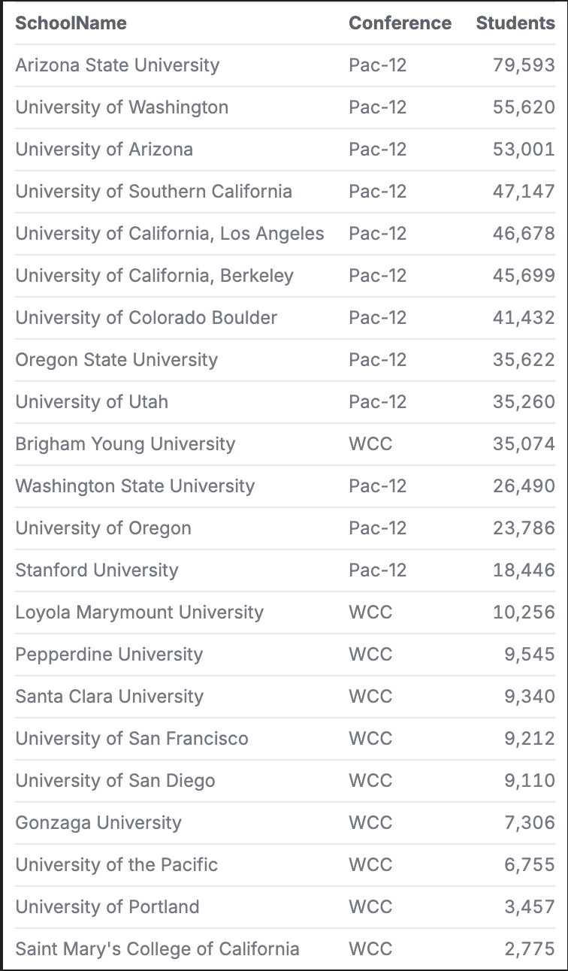

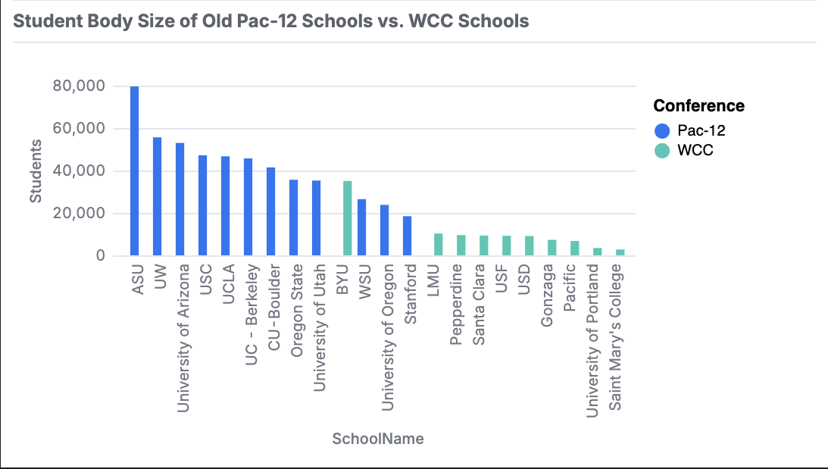

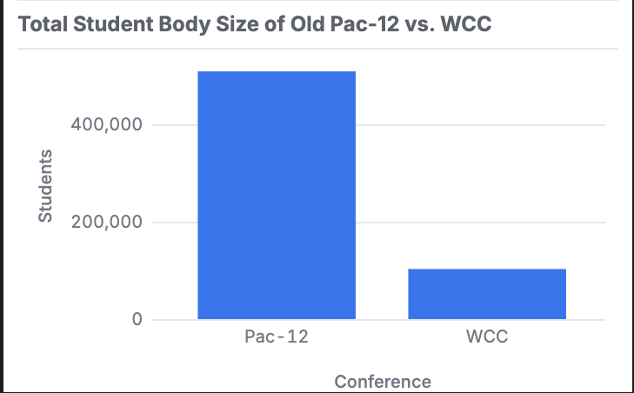

**How does Gonzaga compare to the new Pac-12 schools with regards to student body size?**

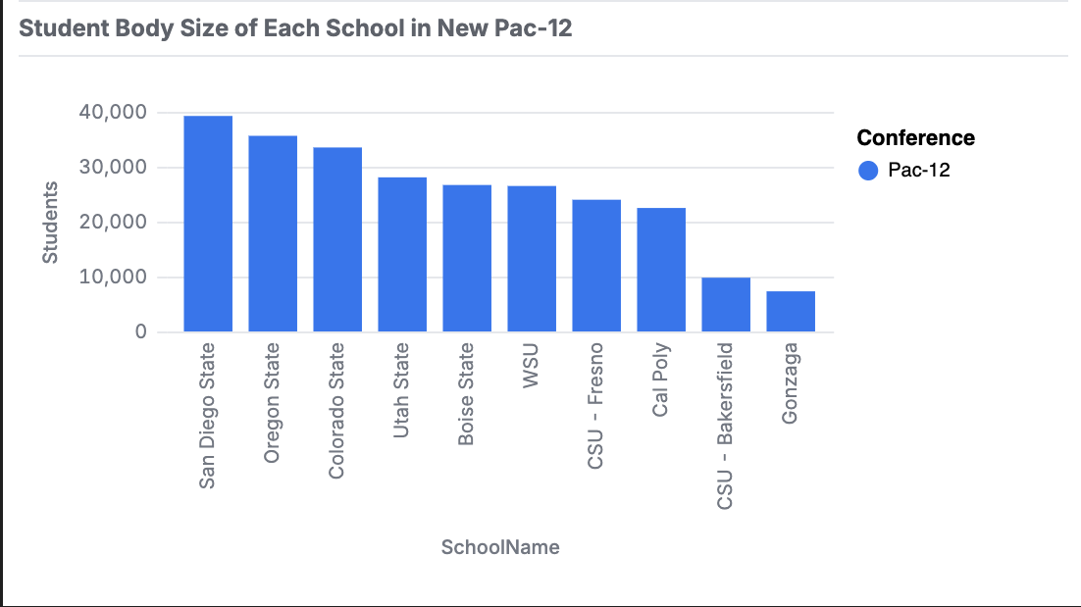

**How do WCC schools compare to the old Pac-12 schools with regards to student retention rates?**

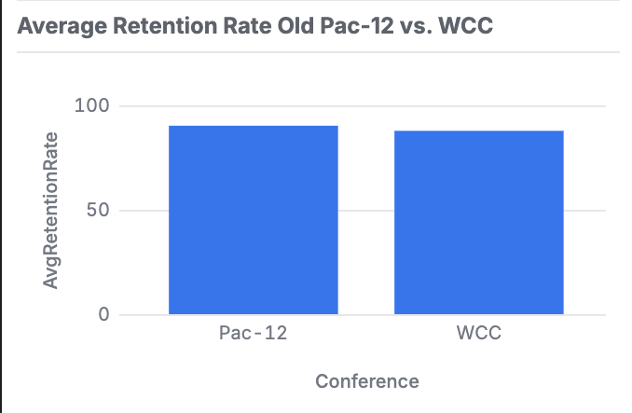

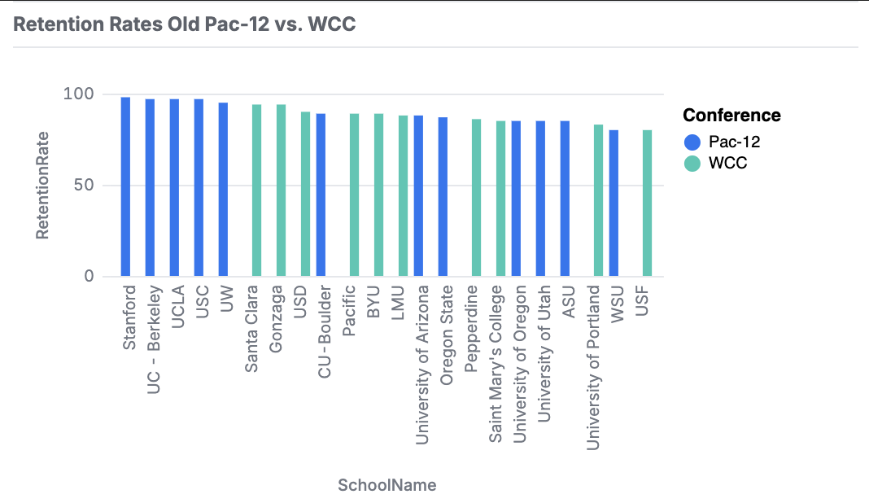

**How does Gonzaga compare to the new Pac-12 schools with regards to retention rates?**

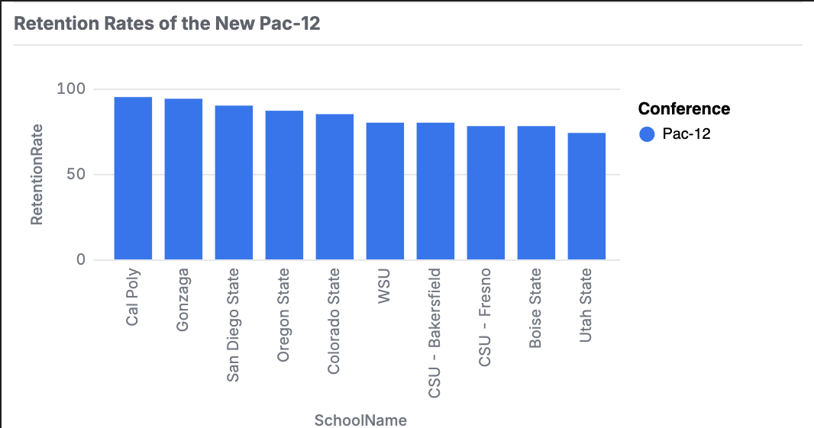

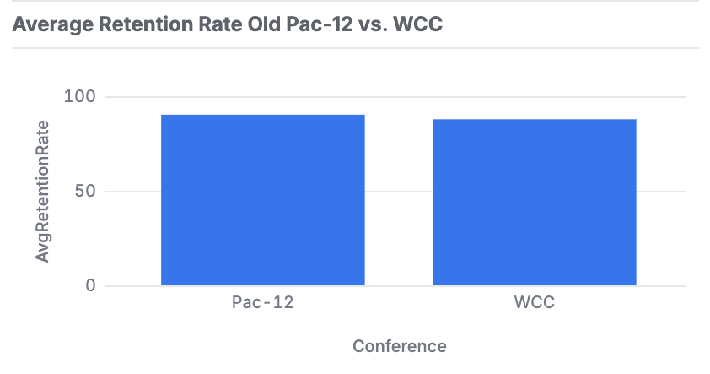

**How do WCC schools compare to the old Pac-12 schools with regards to student graduation rates?**

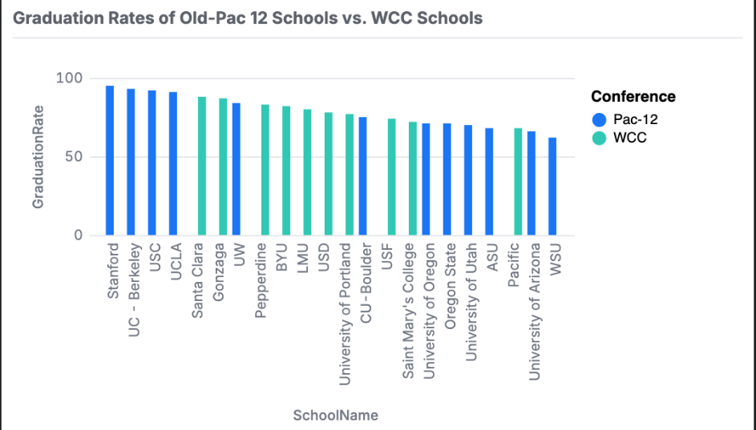

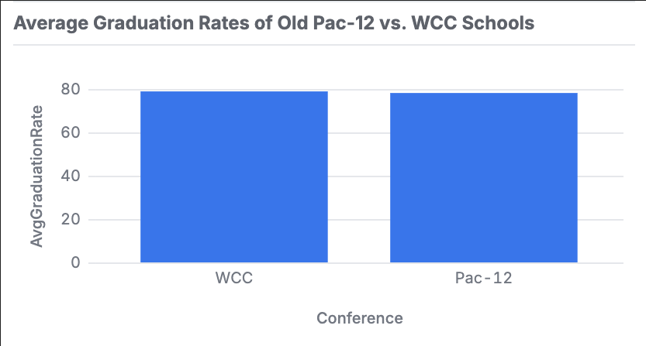

**How does Gonzaga compare to the new Pac-12 schools with regards to graduation rates?**

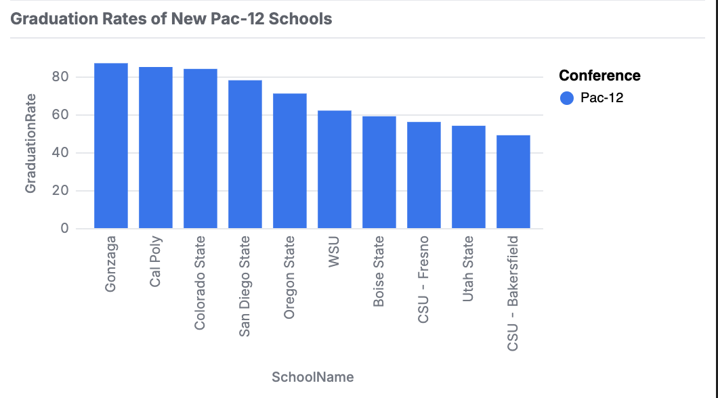

**How do WCC schools compare to the old Pac-12 schools with regards to endowment amount?**

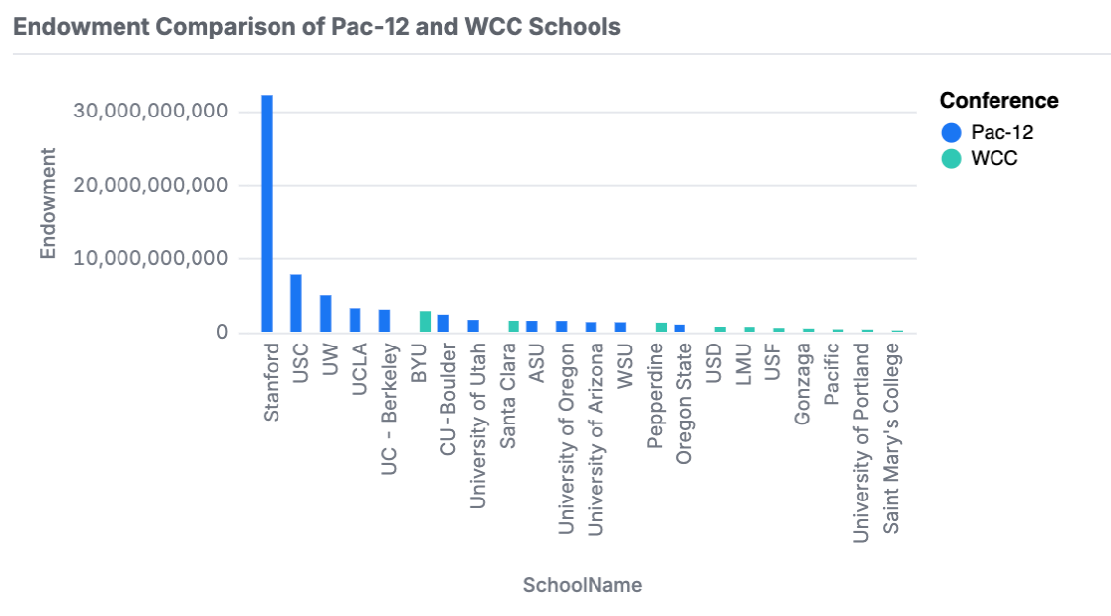

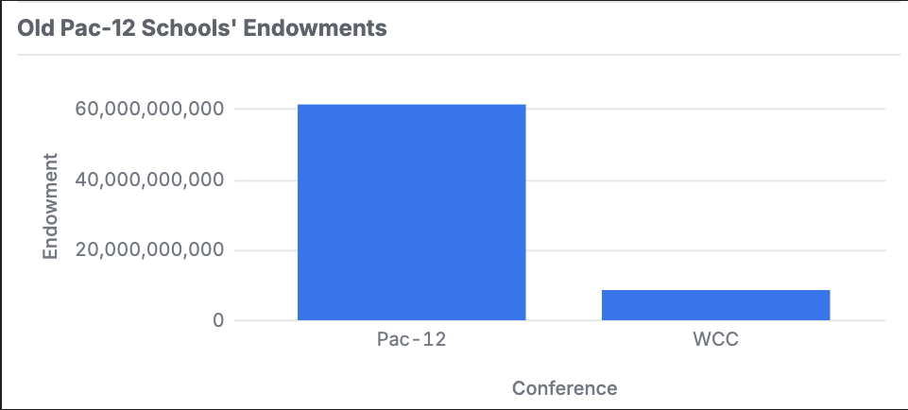

**How does Gonzaga compare to the new Pac-12 schools with regards to endowment amount?**

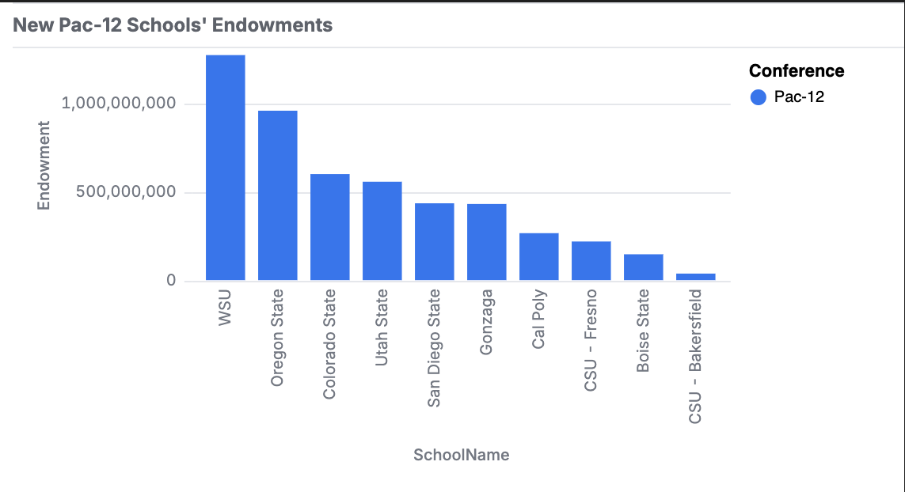

**How does graduate student enrollment differ between schools in Washington State in 2024? How did it differ in 2019?**

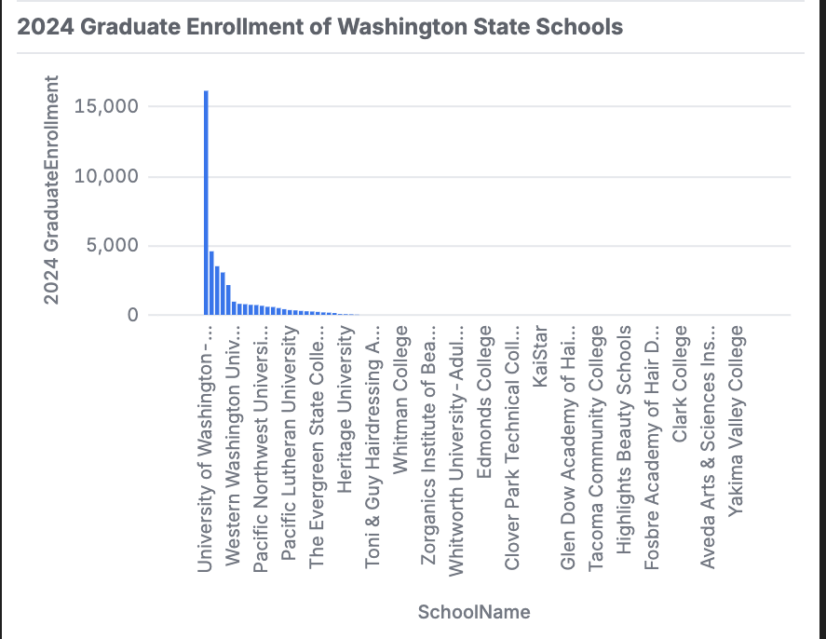

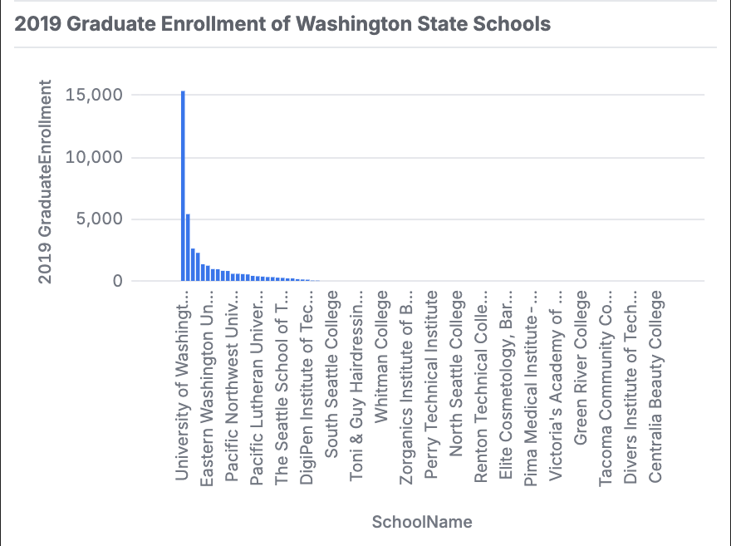

**What is the total graduate student enrollment trend in Washington state over the past 10 years (since the 2014-15 academic year)**

**How does graduate student enrollment differ by school sector in Washington State (Public / Private / For-Profit / Non-Profit) in 2024? How did it differ in 2019?**

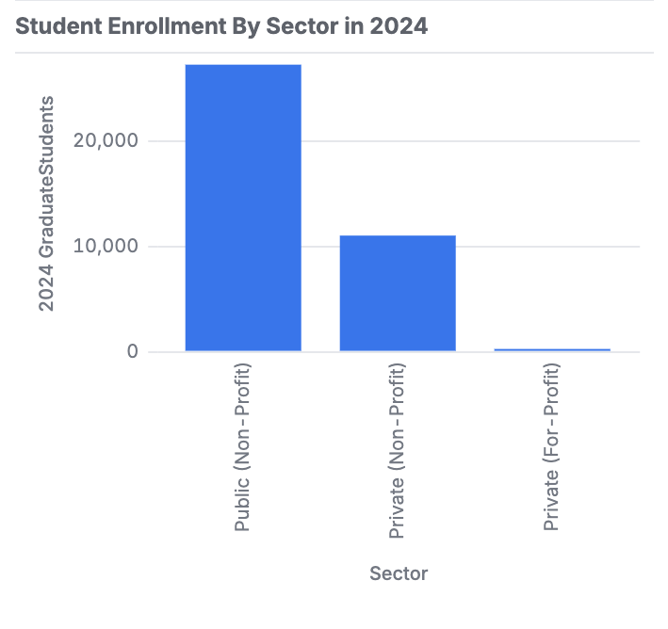

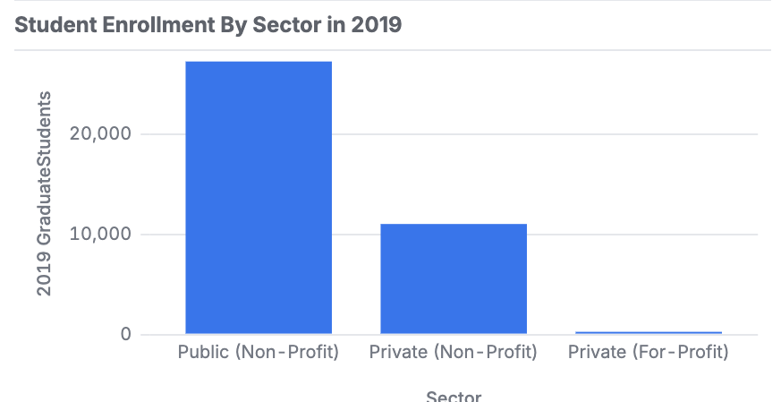

**What are the year over year trends in graduate student enrollment by sector for Washington State Schools (public/private, for-profit/not-for-profit) in the last ten years (2014-15AY to 2023-24AY)?**

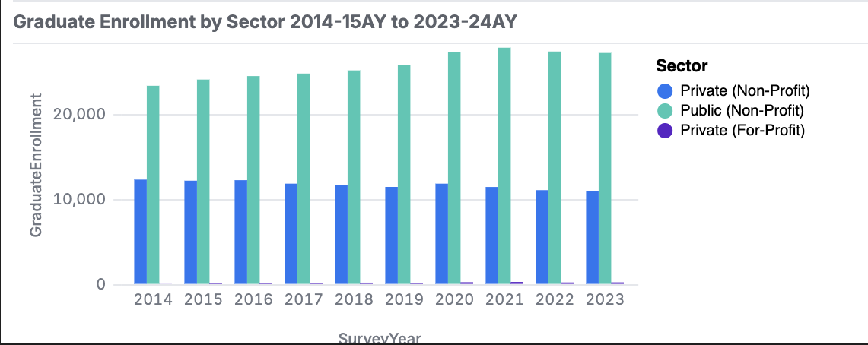

**How does graduate student enrollment differ between schools in Washington State with regards to race in 2024?**

**How did graduate student enrollment differ in Washington State with regards to race in 2019?**

**How does graduate student enrollment differ between schools in Washington State with regards to gender in 2024?**

**How did graduate student enrollment differ in Washington State schools with regards to gender in 2019?**

